Water modular draft
Module 1: Water is life
Water is life, the great connector.
This intro will relate to maps of water systems… illustrate the interconnectedness of water systems and ecologies? … and the role of watersheds as sinks for pollution??
The philosophical and historical aspects of water and life have been greatly documented – we do not wish to reiterate these arguments and observations at length. We wish to focus on water in urban areas: the current relationship between cities and the water resources that sustain them; and, conceptualising the relationship that eco-cities will have with water (this forms an integral part of our movement towards defining the eco-city)
In this chapter we argue that there must be a conscious move back to water-oriented development in eco-cities at all scales. We must ask whether eco-cities can forge a new relationship between urban systems and water systems that not only restore the natural balance but allows cities to take a leading role in the remediation of the ecologies?
Thoughts/quotes:
“We forget that the water cycle and the life cycle are one.” - Jacques Cousteau
“Water is quite literally a source of life and prosperity and a cause of death and
devastation.” : 5

Module 2: Water is cities
It is no coincidence that the earliest urban development occurred near waterways, especially in fertile river valleys. Urban life depends on the production of agricultural surplus and adequate water resources. Nothing that occurs in the city is separate from nature, they are all subject to metabolic interaction. The Tigris, Euphrates, Indus, Nile and Yellow Rivers supported the growth of the earliest urban populations across the globe.

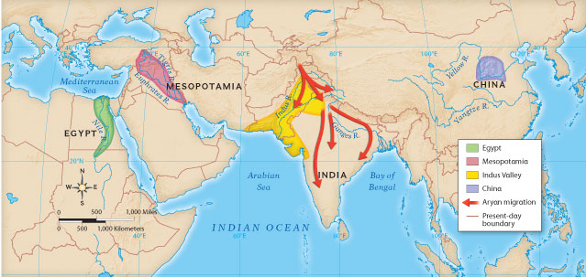

The growth of the first cities ebbed and flowed with the waterways that sustained them.

The growth of urban areas has presented various challenges for obtaining a stable and adequate water supply throughout history .

3: Characterizing artificial cities/The artificial city’s relationship with water (synthetic city could be better?) – “water flows uphill, towards money” (must find person quoted)
“The twentieth century has been one of intensive water control” : 15
- Hydraulic mission – macro-level – the twentieth century’s approach to water resources management may be characterised as a “hydraulic mission” that sought to provide water for human use in cities and regional agriculture through large-scale engineering projects
The hydraulic mission extended the reach of cities in accessing water and contributed the growth of many urban areas at this time.

The engineering approach of the twentieth century’s modernist “hydraulic mission”…succeeded in some respects but failed in critical ways also (environment, poor people, slums)…
“These investments in institutions and hydraulic infrastructure were clearly a pre-condition to harnessing hydrology for sustained and broad-based growth and development.” : 7

This has facilitated an expansion of the water and ecological “footprint” of cities (however, they are also heavily impacted by the consumptive patterns and preferences of urban dwellers etc.)

The hydraulic mission of the twentieth century has increased the actual and epistemic distance between urban populations and the natural resources that sustain them.
In this way, modern cities are artificial cities – they use advanced tools and tricks to maintain their systems and extend their reach beyond the limits of the local. However, these limits cannot be pushed back forever…

Over-extraction from surface and groundwater resources is an increasingly prominent problem facing many regions globally.
Groundwater depletion may lead to of saltwater intrusion and land subsidence .
e.g. The water table under the north china plain has dropped approximately 20 metres since 1980 due to extraction of groundwater beyond the rate of recharge (find ref, in notes)

Polluting cities – Watersheds and tributaries are often the final destination of pollutants. Pollution from domestic and industrial sources further reduces peoples’ access to water globally. Nitrates from agriculture are the most common chemical contaminant of groundwater aquifers globally. It has been estimated that industry dumps 300-400 mega tons of polluted waste into water systems each year across the globe (UNWATER FIND REF). In developing countries 70% of industrial waste and 80% of sewage are discharged untreated directly into water bodies (UNWATER FIND REF). Beyond direct water pollution, air borne and soil based toxins inevitably make their way through the water systems. The fluidity makes pinning down responsibility with the polluter very difficult.

4: Eco-cities’ relationship with water: harnessing hydrology – towards accountability; cities as centres of remediation
- Ecological mission – seeks balance between extraction and replenishment of resources
- new hydraulic mission: to
  - the new hydraulic mission must utilise both bottom-up and top-down approaches. I
- City as a filter –
- If we conceptualise of the City as a novel/managed ecosystem we are able to focus on the performance of ecosystem services that can contribute to remediation of the urban environment. Modern cities must mimic natural processes in order to become true eco-cities?
  - Possible example: http://www.pluspool.org/design/
- The eco-city is an absorbent city? Stormwater runoff/green water utilised
  - Stats on stormwater runoff that goes straight into oceans
    - Micro-level solution: waterbench
- City as ecosystem: managed/novel? Emma Marris – not trying to
- Reducing footprint of cities? Densification will mean more people per m² which will tend to expand ecological footprint but we must ask whether it is possible to reduce the footprint of cities per capita?

